Experiment 07

Aim: To create a knowledge base for a Rule based Expert System in a real world scenario using FOL in PROLOG.

Theory:
Prolog, as a declarative programming language grounded in logic, offers a robust framework for building expert systems by encoding domain-specific knowledge. In the context of academic enrollment, Prolog can effectively manage and manipulate data regarding students and their enrolled courses.

Facts:
Facts in Prolog are fundamental statements about relationships or properties. In this scenario, facts represent the enrollment status of students in particular courses. Each enrolled_in/2 fact states that a student is enrolled in a specific course. For instance:
enrolled_in(bhavesh, math).
enrolled_in(bhavesh, physics).
enrolled_in(jesica, biology).
enrolled_in(jesica, chemistry).
enrolled_in(karuna, math).
enrolled_in(karuna, chemistry).
These facts convey who is enrolled in which course.

Rules and queries:-
CODE:-
% Define facts
enrolled_in(bhavesh, math).
enrolled_in(bhavesh, physics).
enrolled_in(jesica, biology).
enrolled_in(jesica, chemistry).
enrolled_in(karuna, math).
enrolled_in(karuna, chemistry).

% Define rules
enrolled_in_course(Student, Course) :-
enrolled_in(Student, Course).

courses_enrolled_in(Student, Courses) :-
findall(Course, enrolled_in(Student, Course), Courses).

students_enrolled_in(Course, Students) :-
findall(Student, enrolled_in(Student, Course), Students).

taking_course(Student, Course) :-
enrolled_in(Student, Course),
format('~w is taking ~w.~n', [Student, Course]).

enrolled_in_multiple_courses(Student) :-
enrolled_in(Student, Course1),
enrolled_in(Student, Course2),
Course1 \= Course2.

courses_with_multiple_students(Course) :-
enrolled_in(Student1, Course),
enrolled_in(Student2, Course),
Student1 \= Student2.

Output:-
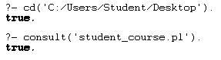
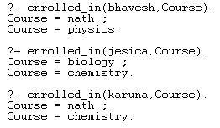
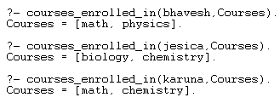
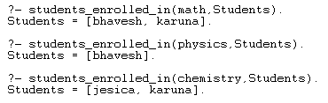
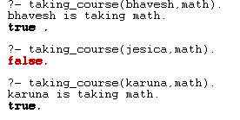
For example:

?- enrolled_in_course(bhavesh, Course).
?- courses_enrolled_in(bhavesh, Courses).
?- students_enrolled_in(math, Students).
?- taking_course(bhavesh, Course).
?- enrolled_in_multiple_courses(Student).
?- courses_with_multiple_students(Course).
These queries allow users to retrieve specific information about enrollment status, student-course relationships, and patterns within the enrollment data.

Conclusion:

In this theoretical exploration, we have demonstrated how Prolog can be applied to represent and reason about academic enrollment data. By defining facts to represent student-course relationships and rules to derive conclusions from this data, Prolog enables the development of an expert system capable of querying and analyzing enrollment information. Through the formulation of queries, users can extract meaningful insights and make informed decisions regarding academic enrollment patterns. This theoretical framework lays the groundwork for building a practical expert system to manage academic enrollment processes efficiently.

